**Aimen Shahzad FA23-BSE-111**

**Question no 1:**

**Suppose you want to develop a program for number conversion. Your program should take 4-digit decimal input from user and convert it into a hexa-decimal number. Repeat the process until user enters decimal number 0.**

**Code:**

#making function to convert number to hexadecimal

def hexaconverter(decimal):

#we made a string showing all hexadecimal numbers

    hexa_string="0123456789ABCDEF"

#we made an empty string wee will use this string to store results and print results

    new_string=" "

#if decimal number is zero it will enter in iff condition and will print statement

    if decimal==0:

        print("Hexa-Decimal Number of 0 is also 0")

        exit()

#if number is greater than 0 it will enter is while statement

    while decimal>0:

        reminder=decimal%16

        new_string=hexa_string[reminder]+new_string

        decimal=decimal//16

    print("Hexa-Decimal Number is ",new_string)

#Starting Statement

print("Enter Your Decimal Number to See its output in Hexa-Decimal Form")

#we are taking input

decimal=int(input("Enter Number : "))

#we are calling function

hexaconverter(decimal)

**Results:**

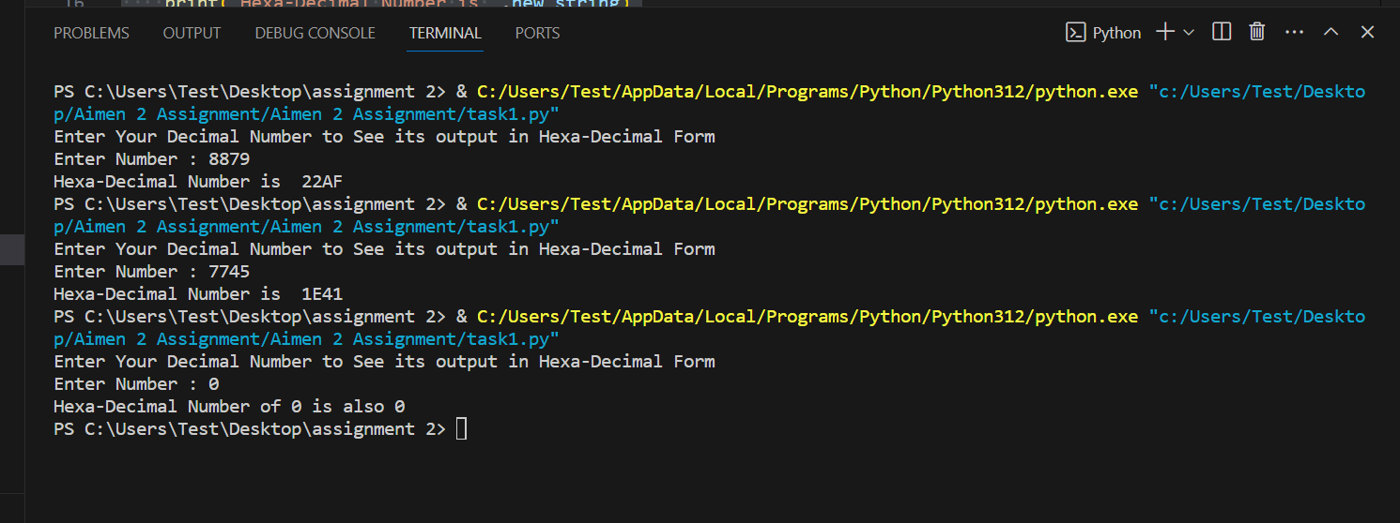

**Question no 2:**

**Write a nested for loop that displays the following output:**

**Code:**

#This will define number of rows

n=5

#starrting for loop will print rows and inner foor loops will print pattern

for i in range(n):

    for x in range(n,i,-1):

        print(" ",end="")

    for y in range(0,i+1,+1):

        print("*","",end="")

    print()

**Results:**

